02 – Chapin – Passionate Kisses
Original key: D Us: Same

Intro piano
Verse melody 2x
[Verse]
D | A | bm | G [2x]
D | f#m | bm | G
[Chorus] D | G | D | G | D | G
Verse Melody [1x]
Verse/Chorus
[Bridge] with melody
Verse [break on last bar]
Chorus [last bar punches on G]
Chorus [elide into melody]
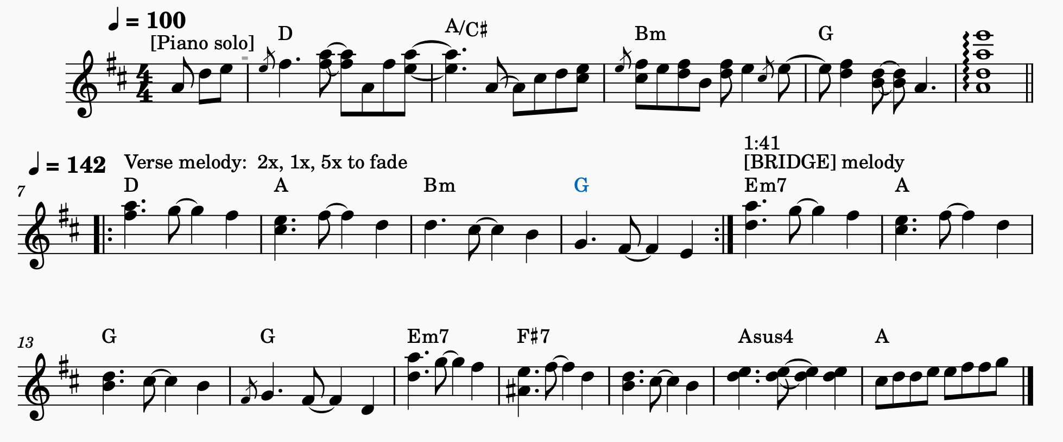
Verse melody [5x over chorus]

